Useful Links
Wilderness Navigation (Map and Compass)
- Class Overview
- Assignment: Declination on your Compass
- Assignment: UTM
- Assignment: Trip Plan
Digital Navigation (GPS)
- Class Overview
- Assignment - Neighborhood Maps
- Assignment - An Outdoor Walkabout

Reviewing Progress
Coassemble has a set of metrics for student progress. Here’s how to see and use these data.
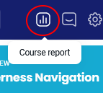
- Once in the Coassemble class overview screen, click on the Course Report button in the top line icon bar.
- Click on the group name OLY NAV SPRING 2024
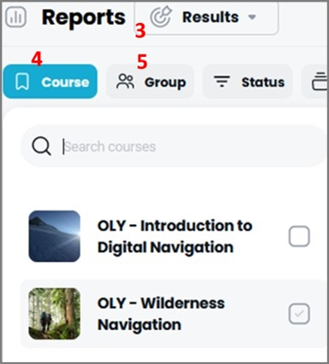
- Click on the Reports button on the left panel and select “Results” from the Reports drop-down at upper-left.
- Filter the Course to the correct course, for example OLY24-Wilderness Navigation.
- Filter the Group to OLY NAV Spring 2024.
At this point, you can review the results. The most useful columns, besides Learner’s name, Username (email), Commenced, and Completed are:
- Progress (0-100) shows the student’s progress through the material, not including the assignments.
- Grade (0-100) shows the students score only on the assignments completed. So, if an assignment hasn’t been completed, then it doesn’t show in this value.
- Pass/Competent shows “Yes” when all the material and all assignments have been completed. It’s “No” until then. This measure shows if the student is done or not.
Evaluating a student’s completion starts with the Pass/Competent column, followed by a look at the Progress column and then a look to see if the student has completed the assignments.

Set up Notices
You can ask Coassemble to tell you when a group member submits an assignment. That means you’ll hear about all the students, not just your set. You can check to see if the student is yours and then either follow up or delete the email. To set up notices:
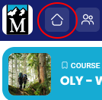
- Once in Coassemble, if you’re looking at a course, you’ll need to get to the Mountaineers Coassemble home. To do this, in the upper left of the screen, click the house icon next to the Mountaineers logo.
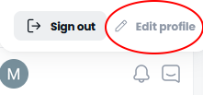
- Hover over your initial in the lower left of the screen and you’ll see your profile. Click on the Edit profile prompt (even though it looks greyed out).
- Check the box to receive notifications via email and Save Changes.
The notification will have a Grade button that will take you to that assignment’s grading area. You can also bookmark the assignment grading screen, because getting there through the system is not straightforward. See the links above.

Grade an Assignment
Once in the grading area for the assignment, you can select a student and view the assignment, usually an uploaded map or image. Students can also add questions or comments in the text box accompanying the assignment. Your job is to look at the submission, give it a grade number (0-100), and record the result. If you believe the student has it right and understands the task, give a 95-100 grade. If not, give the student a score below 80 and return the assignment. When prompted, create a second chance to do the work. If you don’t do this, the student can’t complete the assignment. The basic steps are:
- Click on the student in the Learners column at left. That student’s submission will appear in the right column. Some assignments have multiple parts. For each part:
- Evaluate the student’s submission. There are three kinds of input:
- A link, which will show in a box in blue text. Click the link to view.
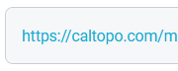
- A text box with the student’s answer.
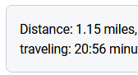
- An image, which will show the filename and type. Click the view button at right.

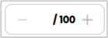
- Provide the grade number in the box. Score successful answers 80-100 and unsuccessful answers less than 80. For instance, I score declination that’s one degree off at 95 and provide feedback asking for an adjustment. The student still passes the assignment.
- Provide feedback in the Feedback text box, especially if the student got something wrong.
- Click the Publish button at bottom right.
- If the grade is failing (less than 80), create a second attempt for the student and return that to the student so they can try again.

Regrade the Assignment
If you need to correct your grade, you can “unpublish” a graded assignment. Here’s how:
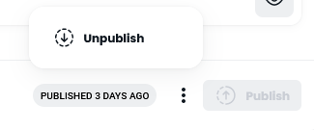
- Scroll to the greyed-out Publish button and click on the three vertical dots.
- This reveals an “Unpublish” button, which you use to open the assignment grading for adjustment.
- When done, Publish again.

